Dashboard1: Competitive Marketing Analysis Report
Executive Overview
This report provides an in-depth analysis of sales performance across various marketing channels, including Online, Social Media, Stores, and Outlets. The analysis focuses on total sales, return on investment (ROI), and sales distribution by product, channel, and region.

Visualization1: Sales Overview

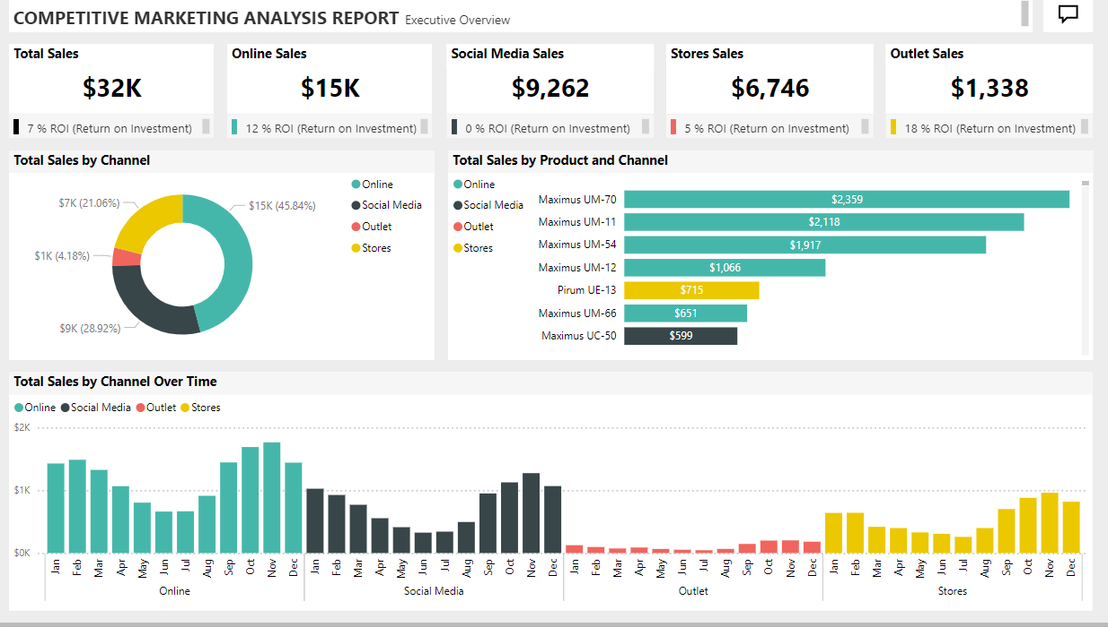

- Total Sales: The dashboard highlights the overall sales performance across all channels. The total sales are split into four major channels: Online, Social Media, Stores, and Outlets. This gives a clear understanding of which channels contribute the most to the overall revenue.
- Online Sales: Online sales form the largest portion of total sales. The ROI from this channel is significantly higher compared to others, indicating strong digital marketing performance and efficient use of online sales platforms.
- Social Media Sales: Social Media sales show moderate contribution to total revenue but exhibit room for improvement in terms of ROI. This suggests the need to evaluate social media marketing strategies and optimize ad spend.
- Stores and Outlets Sales: Store sales are steady, with a moderate ROI, while Outlet sales, though lower in volume, show the highest ROI. This could imply effective localized or seasonal marketing campaigns for Outlets.
- Sales by Channel: The pie chart visualization provides a distribution of sales by channel, showcasing Online as the top-performing channel. Social Media follows, while Outlets and Stores contribute smaller shares. The graph offers a snapshot of the reliance on each channel.
- Sales by Product and Channel: The bar chart breaks down sales performance by individual product categories across channels. This allows for insights into which products perform best on specific platforms. For example, certain products show higher sales in online channels, whereas others might sell better in physical stores or outlets.
- Sales by Channel Over Time: The line and bar graph depicting sales trends over time for each channel reveals seasonal patterns. For instance, online sales show consistent growth with peaks during certain months, potentially corresponding to promotional campaigns or holiday periods. In contrast, store and outlet sales appear to have steady but less pronounced fluctuations over time.

Visualization2: Geographical Sales Analysis

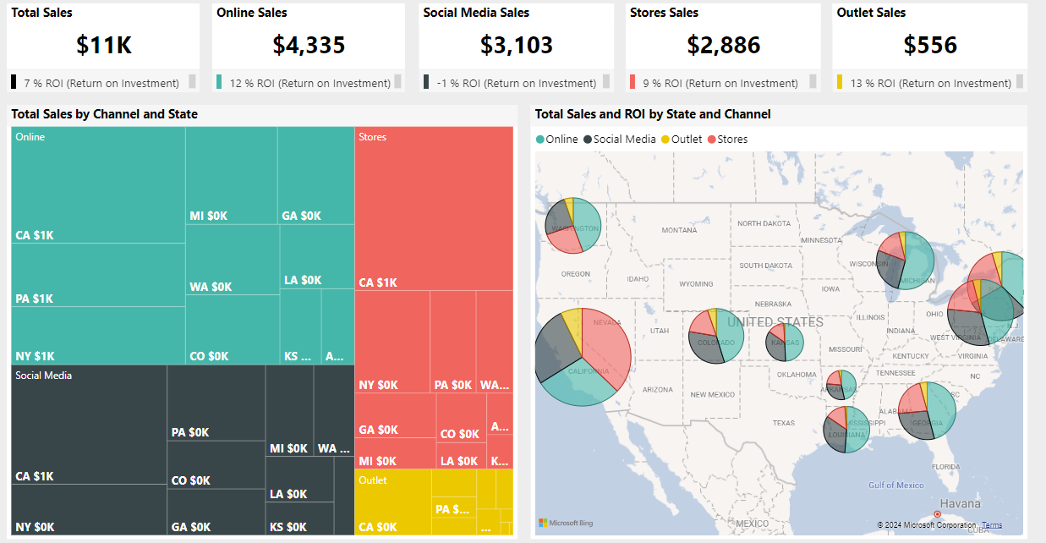

- Sales by Channel and State: The treemap visualization categorizes sales by state and channel, showing which regions contribute the most to each channel’s revenue. For example, online sales may dominate in certain states, while stores or outlets perform better in others. This geographic insight is valuable for targeted regional marketing efforts.
- Sales and ROI by State and Channel: The map visual further enhances the geographic analysis by overlaying ROI performance on sales distribution. This allows for identifying high-performing regions where marketing strategies are most effective and regions that may require additional focus

Visualization3: ROI Analysis

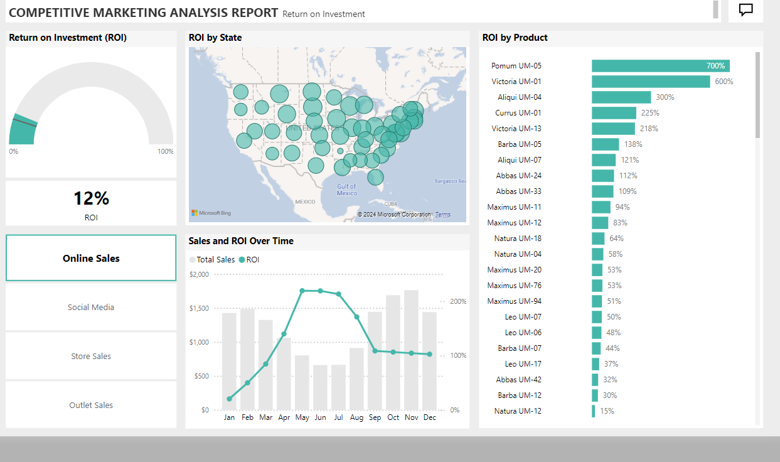

- Overall ROI: The overall ROI indicator shows the profitability of marketing efforts. Although some channels, like Online and Outlets, have higher ROI, others, such as Social Media, may need optimization to increase profitability.
- ROI by Product: A detailed analysis of ROI by product helps to pinpoint which products deliver the most return across all channels. Certain product categories outperform others significantly, suggesting they may be worth more focus in marketing and production efforts.
- ROI by State: The map visualization also ties sales to ROI by state, helping to visualize which geographic areas are the most profitable and where adjustments in marketing strategies may be needed to enhance returns.

Recommendations from Dashboard:
- Optimize Social Media Strategy: Social Media sales are moderate, but ROI is lower compared to other channels. It would be beneficial to reassess the advertising strategies or optimize content to increase engagement and sales.
- Expand Online Sales: Online sales dominate in both volume and ROI, suggesting that additional investment in this channel could yield even higher returns. Further promotions and product offerings in this space should be explored.
- Leverage Outlet Success: Outlet sales, although lower in volume, have the highest ROI. Exploring ways to replicate this success in stores or other channels might lead to overall improved profitability.
- Regional Focus: The geographic sales breakdown indicates that certain states contribute significantly to online or outlet sales. Focused marketing campaigns targeting these high-performing regions, combined with efforts to boost underperforming areas, could enhance overall revenue.
- Product Performance: High ROI products should be promoted more aggressively across all channels. Lesser-performing products may need reevaluation in terms of pricing or marketing to improve their contribution.

Final Dashboard Outcome: This dashboard provides actionable insights into the company's marketing and sales strategies, helping to refine efforts across channels, products, and regions for improved profitability and performance.

Project 2: Supply Chain Analytics Report
This report provides insights into the supply chain performance, focusing on product demand types, backorder issues, and the influence of various factors on the likelihood of products being on backorder. The analysis spans across different regions, helping to identify where operational inefficiencies or demand challenges may exist.

Visualization1: Backorder Analysis:
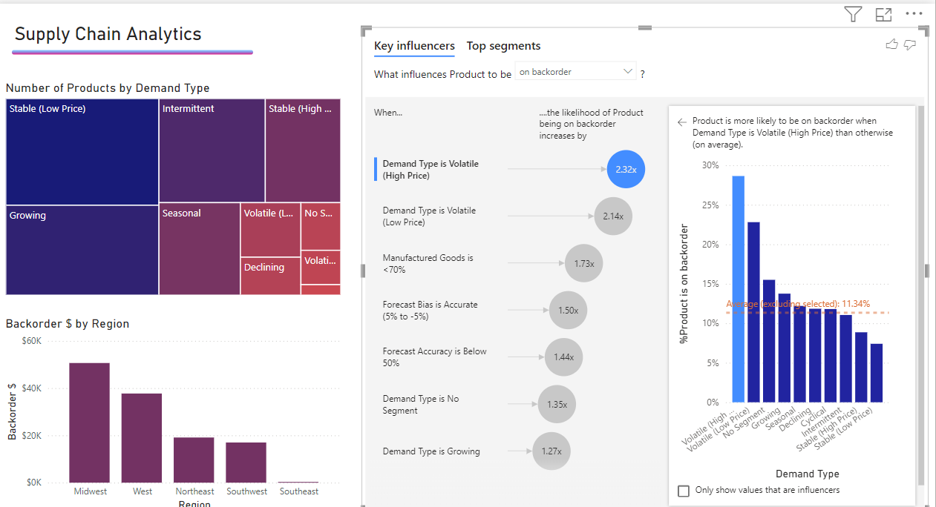

1. Product Demand Analysis:
Number of Products by Demand Type: The visualization categorizes products based on demand type, such as Stable (Low Price), Growing, Intermittent, and Volatile. This breakdown highlights which types of products have the most stable versus fluctuating demand patterns. For example, stable low-priced products make up a significant portion, while products in volatile demand categories may need closer monitoring due to supply chain challenges.
2. Backorder Analysis:
Backorder by Region: This bar chart shows the distribution of backorders across different regions, giving a clear view of where backorders are most prevalent. Regions like the Midwest and West have more significant backorder issues compared to others. This helps in targeting areas that require operational improvements or additional stock to meet demand more effectively.
3. Influencing Factors on Backorders:
- Key Influencers: The key influencers visualization provides insight into the factors that increase the likelihood of a product being on backorder. Demand type plays a significant role, especially for products that are volatile in price, both high and low. Other factors such as the percentage of manufactured goods, forecast accuracy, and growth trends also contribute to the backorder risk. This analysis helps in understanding which variables should be closely monitored to reduce backorders.

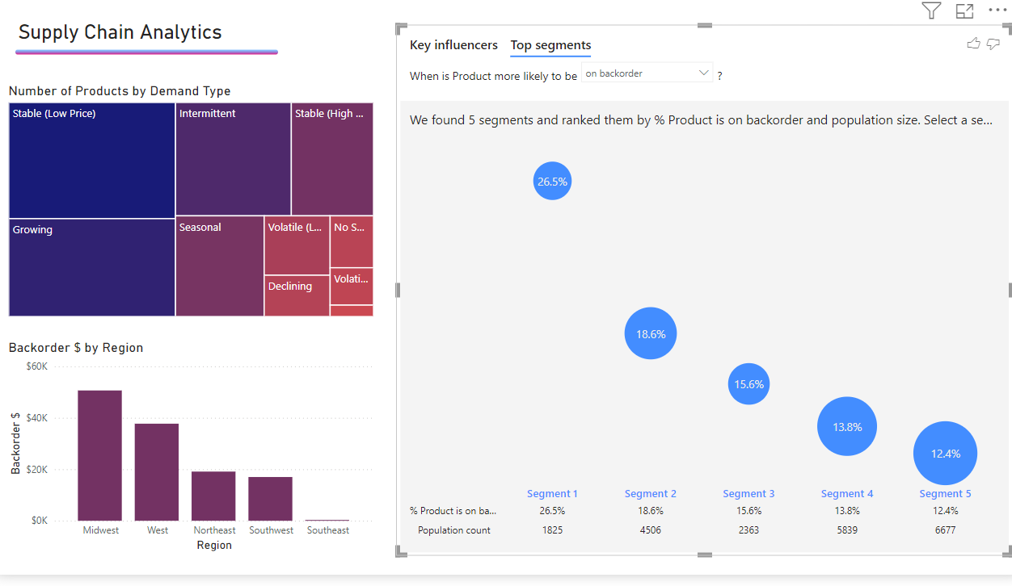

- Top Segments: The segmentation analysis identifies key product segments that are more likely to experience backorders. The largest segments are ranked based on the percentage of products affected by backorder issues. This visualization is useful for targeting specific product categories for improvement efforts, such as adjusting inventory levels or refining forecast accuracy for higher-risk products.
4. Demand Type and Backorder Likelihood:
- Demand Type Insights: Products with volatile demand, especially those with high prices, are most prone to backorder issues. The analysis shows a significant correlation between demand volatility and backorder frequency. Stable and growing demand products, on the other hand, experience fewer backorders. This suggests that products with predictable demand require less inventory buffer, while those with fluctuating demand need better demand planning and stock management.
5. Regional Performance Insights:
- Backorder $ by Region: The chart visualizes the backorder value across different regions, showing a geographical perspective of supply chain challenges. Some regions show higher backorder volumes, indicating potential supply chain inefficiencies, such as delayed shipments, insufficient inventory, or demand forecast errors. Monitoring these regions more closely could help reduce delays and improve service levels.

Recommendations:
- Focus on Volatile Demand Products: Products classified under volatile demand (both high and low price) are significantly more likely to be on backorder. Prioritizing better forecasting techniques and inventory strategies for these products could help minimize backorder issues.
- Regional Backorder Optimization: The Midwest and West regions show the highest instances of backorders. Additional inventory or improved supply chain processes could mitigate delays in these regions.
- Forecasting Accuracy: Improving forecasting accuracy, especially for volatile products, is crucial. Focus on refining demand prediction models to ensure that stock levels meet actual demand patterns, especially for high-risk product categories.
- Segment-Based Planning: Pay special attention to the top product segments identified as most at risk for backorders. Adjusting procurement strategies for these segments can reduce supply chain bottlenecks and improve fulfillment rates.

Final Dashboard Outcome: This dashboard provides actionable insights to optimize supply chain operations by identifying high-risk product categories and regions, enabling targeted improvements to reduce backorders and improve overall efficiency.

